**Project:** Facilities

* Please open the solution inside Visual Studio 2015 or above version.

**To get the publish contents of the FacilitiesServices project:**

* Please right click on the FacilitiesServices project (Service application) and click publish to get the published files (only File system)
* This will create a folder with published contents in it.
* Please deploy these files on IIS

**To get the publish contents of the angular project (to be repeated for each of angular project):**

* Inside the angular project please open go to  “**ProjectRootDirectory**\src\app\shared” and open " “globalvariable.ts" file
* Change the API service link to the URL of your hosted API on your IIS .i.e value of "readonly baseAPIUrl: string = 'URL OF API HOSTED IN IIS' "
* Please open node command prompt in admin mode
* Please go to the root directory of the angular project in command prompt
* Run "**ng build -prod -aot --buildOptimizer**" command in the node command prompt
* (This command will create "**dist**" folder inside the root directory of angular application which contains published files of angular application)
* Please open index.html file and change  "<base href="/">" to "<base href="">"
* Please deploy these files on IIS

**Guidelines to deploy the published contents on the IIS:**

* Please open IIS using either “inetmgr” or “IIS” on the windows Run command. (Windows button + R )
* Please expand the default sites node in the IIS manager as shown below:

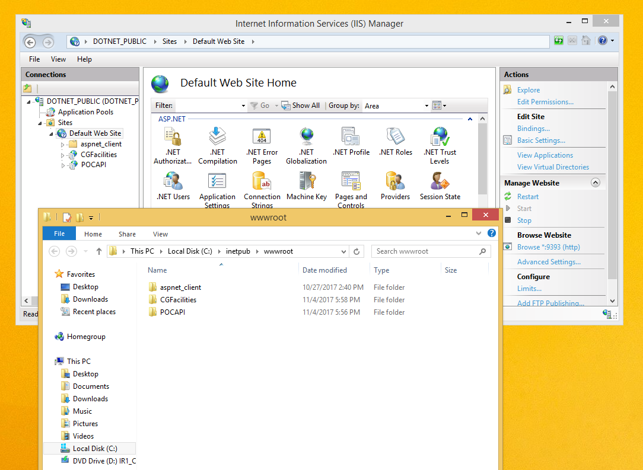

* Right click on “Default Web Site” node and click “Expand”. This will take you to the default port location of IIS where we can deploy the site and services. The location generally is “C:\inetpub\wwwroot”.
* Please Create 4 folders here, 1 for each of the 3 angular applications and 1 for services. For example as shown in the image above, we have created 2 folders, CGFacilities for angular project and “POCAPI” for services.

**Steps for deploying the angular application:**

* Please copy all the contents of the “dist” folder inside the angular project folder for example as shown “CGFacilities” created for angular application as illustrated above.
* In the IIS manager right click on the “CGFacilities” node and click on “Convert to application” node in the pop up. You will be presented a dialog box “Add Application” thereafter.
* Please click on OK and we should be all ready now. The application is hosted on IIS.
* To check the working. Please click on the “CGFacilities” node and click “Manage application” and browse as show below:

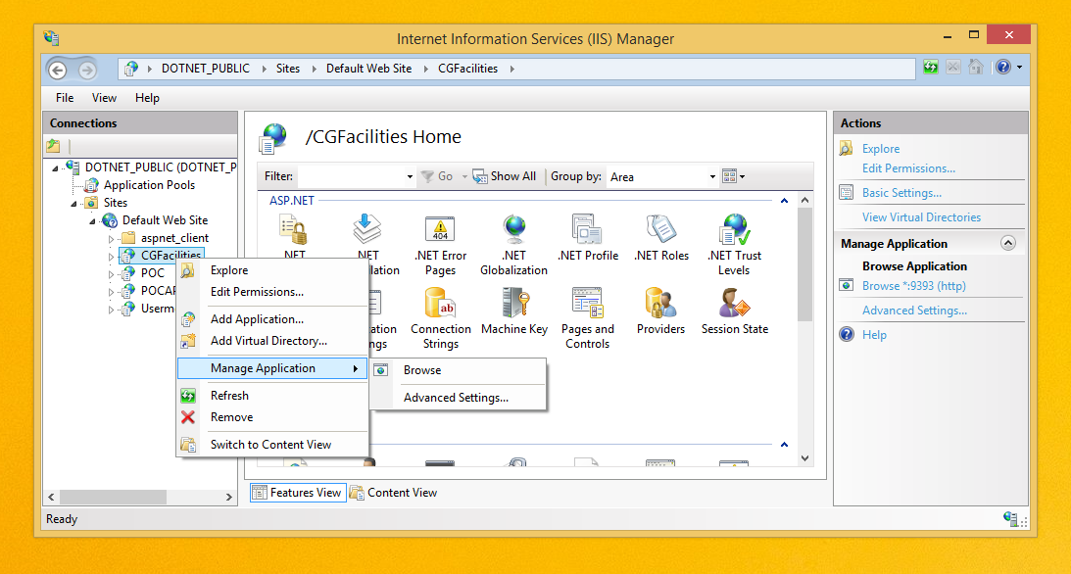

**Steps for deploying the angular application:**

* Please copy all the published contents of the services inside the folder created for example “POCAPI”.
* In the IIS manager right click on the “POCAPI” node and click on “Convert to application” node in the pop up. You will be presented a dialog box “Add Application” thereafter.
* Please click on OK and we should be all ready now. The services are hosted on IIS.
* To check the working. Please click on the “POCAPI” node and click “Manage application” and browse as we checked the angular application deployed.

**Note:**

POCAPI and CGFacilities are just example names used to illustrate the deployment of angular application and services in IIS.